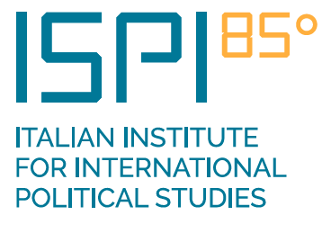

Upcoming Elections for the Next Director-General of the Food and Agriculture Organization

Introduction
The Food and Agriculture Organization (FAO) is a specialized agency of the United Nations that leads international efforts to defeat hunger. Its goal is to achieve food security for all and make sure that people have regular access to enough high-quality food to lead active, healthy lives. With over 194 member states, the FAO works in more than 130 countries worldwide.
The elections for the next director-general of the FAO will take place in 2019. Nominations closed on 28 February 2019 and the procedure provides for the nominated candidates to address the 8-12 April 2019 session of the FAO Council and respond to questions that members of the Council may put to them. It has been agreed that these will take place on Thursday 11 April – 90 minutes will be set aside for each candidate to present and answer questions. A similar procedure follows at the FAO Conference, to be held on 22-29 June 2019, after which the new director-general will be elected by a majority vote, with a procedure involving elimination of the candidate with the least votes in successive ballots, until a majority vote for one candidate is obtained.
The four candidates who have been nominated are:
- Qu Dongyu (China)
- Catherine Geslain-Lanéelle (France)
- Davit Kirvalidze (Georgia)
- Ramesh Chand (India)
Short biographies of the candidates are annexed.

Why a public forum?
The objectives of this exercise are to stimulate public debate, including through engaging the media, on the FAO’s future role, in particular what it needs to do to address key issues in food and agriculture and to help achieve the sustainable development agenda.
The election of a new director-general is an opportune time to consider the ways in which the FAO could better contribute to the challenges the world faces where it has influence – not just in food production but in nutrition, climate change, the environment, economic growth and poverty reduction.
Chatham House, in partnership with the Italian Institute for International Political Studies (ISPI), is organizing a forum in order to open up the FAO election process to a wider global audience of non-governmental stakeholders and the general public interested in the FAO’s future policies and its role in the achievement of the UN’s Sustainable Development Goals. This presents an important opportunity for candidates to lay out their vision for the future of the FAO and its important role in addressing the key issues that face the world in food and agriculture as well as highlighting the personal qualities they could offer in the leadership of the FAO.
The candidates will be asked a series of questions from moderators, members of the audience and the global audience viewing online.
The idea for this proposal is derived from a successful series of events conducted by Chatham House and the Global Health Centre of the Graduate Institute of International and Development Studies in Geneva during the election process for candidates for the director-general of the World Health Organization (WHO) in 2016-17. These were designed as an opportunity for stakeholders – medical professionals, academics, non-governmental organizations, the media and the private sector – to hear from the candidates and put questions to them. The events were webcast to a global audience and there was an active dialogue on Twitter that generated a number of questions subsequently put to the candidates by the moderators.
Chatham House will publish a report after the election reviewing the election process at the FAO, including the value of the public fora. It will also consider whether there are elements in other election processes in UN agencies from which lessons can be learned relevant to the FAO.
CANDIDATE BIOGRAPHIES
CHINA
Qu Dongyu
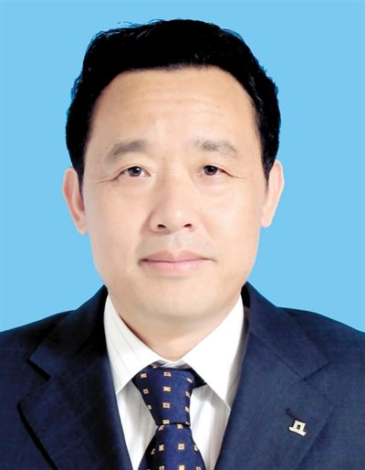
Dr Qu Dongyu, vice-minister of Agriculture and Rural Affairs, is an expert on agriculture and rural areas. He has worked in this area for more than 30 years building up a wealth of experience covering policy planning, administrative management, reform and innovation and international cooperation. Before joining the Ministry, he worked at the Chinese Academy of Agricultural Sciences where he made notable achievements in conducting research and innovation, raising rural income, reducing poverty through science and technology and building a quality assessment system for agro-produce. From 2008-25 he worked in the government of Ningxia Hui Autonomous Region, where he introduced policies on developing local specialty industries where he applied new approaches to agricultural publications and rural tourism and provided startup microlending to young and female farmers.
Since being appointed vice-minister in 2015, he has spearheaded a number of measures that have proven instrumental in taking China’s agricultural development top a new level. These include efforts to develop important agricultural policies and reforms for rural areas, advancing the market-oriented development of agriculture supported by information technologies, instituting exchange mechanisms on urban agriculture in large and medium-sized cities and promoting brand building and specialty industries.
Dr Qu has also been deeply engaged in international cooperation at the United Nations, G20, APEC and other fora. He has been in charge of China’s agri-business cooperation with Asian, African and Latin American countries and China’s main trading partners of agri-produce. He has championed the implementation of flagship projects and a long-term mechanism for China-FAO South-South multilateral cooperation, thereby playing a constructive role in regional and global agricultural development.
FRANCE
Catherine Geslain-Lanéelle
Ms Geslain-Lanéelle is an engineer in agronomy, former director-general of the French Ministry of Agriculture and Food and former executive director of the European Food Safety Authority (EFSA). She is the European Union’s sole candidate following the decision adopted on 15 October 2018 by the Council of the European Union.
Ms Geslain-Lanéelle has proven her ability to manage complex and large-scale organizations operating in a multicultural environment as well as high-level professional experience in the fields of food systems, rural development and food security both in France and in Europe. She has held high-ranking positions at the French Ministry of Agriculture and Food, going from head of international exchanges (food aid and international cooperation), to director-general for food and finally director-general for the economic and environmental performance of businesses.
At the European level, having worked at the European Commission as an expert on food safety for consumers, she then led the European Food Safety Authority (EFSA) for over seven years.
Throughout her career, Catherine Geslain-Lanéelle has used her scientific and technical expertise of agriculture, fisheries, forestry, rural development, food systems and nutrition to design and implement public agricultural and food policies at national, European and international levels. For almost 20 years, she has helped shape France’s policies and led major international initiatives such as the creation of the ‘4 per 1000: Soils for food security and climate’ initiative. Ms Geslain-Lanéelle has also sat on numerous European and international committees including the Codex Committee on General Principles.
GEORGIA
Davit Kirvalidze
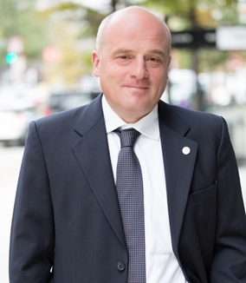
Currently serving as advisor to the Prime Minister of Georgia on agriculture and rural development, Dr Davit Kirvalidze brings 28 years of leadership and management experience in agriculture, specifically focused on development policy, value-added agriculture and private sector development. Dr Kirvalidze served two terms as minister of agriculture of Georgia (2000–04 and 2012–13 respectively). As minister, he led efforts in institutional reforms to increase productivity and competitiveness, expand access to finance, stimulate export growth and attract investments into Georgian agriculture sector and food industry. Prior to serving as Georgia’s minister of agriculture, he was elected as a Member of Parliament and served from 1999–2000 where he chaired the Agrarian Issues Committee.
Dr Kirvalidze specializes in issues related to rural and agricultural development, agricultural supply-value chains, small and medium enterprises (SME) and service providers. His wide-ranging experience encompasses all aspects of agriculture and agribusiness including practical experience as a farmer. He has worked with numerous international organizations and programmes and Dr Kirvalidze has represented the Government of Georgia to the FAO and IFAD.
From 2006–12, as a senior advisor to the president of Cultivating New Frontiers in Agriculture (CNFA), Dr Kirvalidze provided strategic planning expertise leading to the awarding of 15 projects in a number of countries with funding of over $100 million. Since 2014, he has continued to guide this, leading the organization as a member of its Board of Directors.
Dr Kirvalidze holds a Doctor of Philosophy in Agricultural Sciences as well as a degree in Soil Science and Agro-chemistry. He was a Fulbright Scholar in 2005–06 at the University of Maryland and undertook work on strategies for sustainable agricultural and rural development in transition economies. He is fluent in Georgian, English and Russian.
INDIA
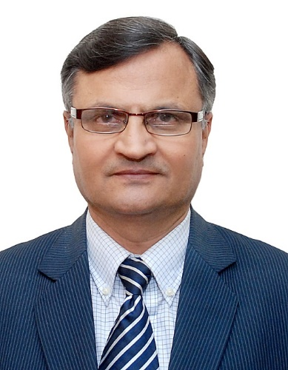
Ramesh Chand
Dr Ramesh Chand is a renowned Indian agricultural economist and policymaker. Since 2015, he has been member of the National Institution for Transforming India (NITI) Aayog in the rank of union minister of state for the government of India. NITI Aayog, formerly Planning Commission of India, is a policy think-tank chaired by the prime minister of India. In this position, Dr Chand is directly steering India's development agenda in agriculture and food security. He is also providing policy inputs to central ministries and state governments in water resources, SDGs, poverty alleviation, forests and the environment, sustainable livelihood, smallholder development, food processing and agri-technology.
Dr Chand has served in eminent academic positions including: national professor at the Indian Council of Agricultural Research for five years, principal scientist at the National Institute of Agricultural Economics and Policy Research in New Delhi for 10 years, professor at the Institute of Economic Growth, University of Delhi, professor at Punjab Agricultural University, Ludhiana, India, visiting professor at the University of Wollongong, NSW, Australia and visiting fellow at the Institute of Developing Economies, Chiba Shi Japan. He also headed the National Institute of Agricultural Economics and Policy Research in New Delhi as its director for six years.
He has impacted global agricultural policies and research through various roles including as member of the Board of Trustees of International Wheat and Maize Improvement Centre, Mexico, 2016, member of the Policy Advisory Committee of the Australian Centre for International Agricultural Research, 2016, member of the Food Security Committee of the Global Food Security Council of the World Economic Forum, Geneva, 2016-17.
He has also served as India's nodal officer on agriculture and rural development for SAARC and UNESCAP for six years and was responsible for preparing SAARC Agriculture Vision. In addition, he has advised the government of India on G20 matters as a senior expert and participated in multiple G20 meetings during the presidency of France, Mexico and Russia. Dr Chand has been instrumental in deliberations and preparation of policy recommendations at multiple international events across 20+ countries on topics such as food and nutrition security, poverty, trade and WTO, food and price policy and agriculture growth and development.
MODERATORS
Femi Oke

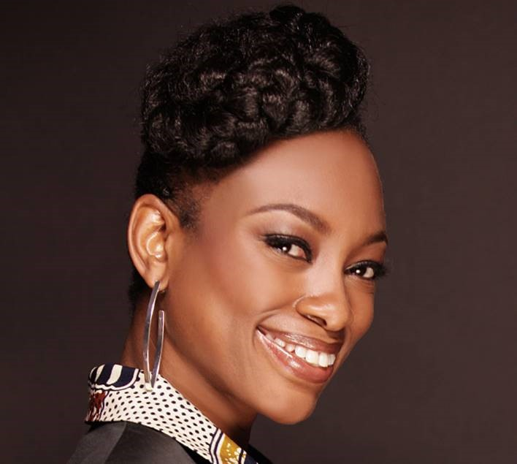
Since the 1980s Femi Oke has reported, produced and presented for the BBC, Channel 5, Channel 4, ITV, Sky Television, CNN International, National Geographic, Al Jazeera and NPR. Her prevalence on local, national and international TV has led to a second career as a moderator and facilitator at global forums and conferences.
Femi has travelled the world hosting high-profile events, leading global conversations and teaching moderating workshops. She can be found facilitating regularly for the likes of the United Nations, the World Bank and the European Commission. Some of her most warmly received appearances include hosting the NBA Africa All Stars event in New Orleans, being mistress of ceremonies for Peter Gabriel at the Witness 25th Anniversary Benefit Gala and launching the Sustainable Development Goals at the United Nations headquarters in New York.

Per Pinstrup-Andersen
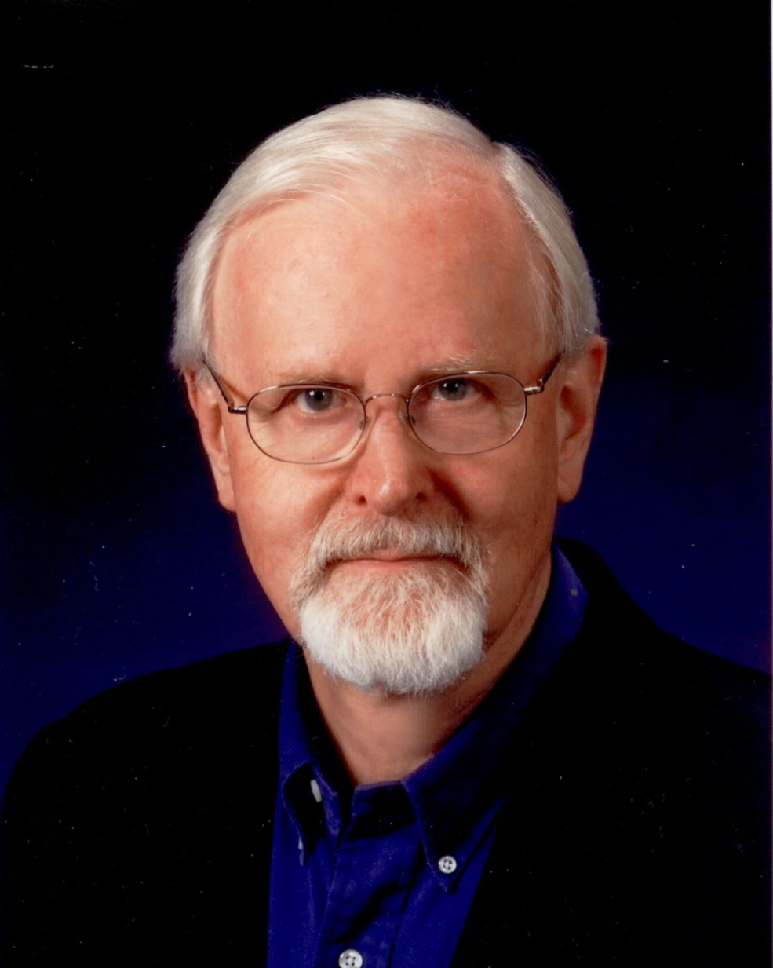
Per Pinstrup-Andersen is professor emeritus at Cornell University and adjunct professor at Copenhagen University. He previously was chairman of the Science Council of the CGIAR, president of the American Agricultural Economics Association (AAEA) and chair of the UN High Level Panel of Experts on Food Security (HLPE). He has a B.S. from Copenhagen University, a M.S. and Ph.D. from Oklahoma State University and honorary doctoral degrees from universities in the United States, the United Kingdom, Netherlands, Switzerland and India.
He is a fellow of the American Association for the Advancement of Science (AAAS) and the American Agricultural Economics Association and is an honorary alumnus at Copenhagen University. He has been a professor at Cornell, Copenhagen and Wageningen universities, director-general and department head at IFPRI and and economist at CIAT. He is the 2001 World Food Prize Laureate and the recipient of several awards for his research and communication of research results. His authorship includes several books and a large number of articles and reports about food and agricultural policy, nutrition economics and related matters.

Gerda Verburg

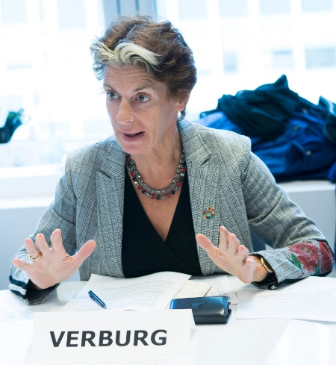
Since August 2016, Gerda Verburg has served as UN assistant secretary-general and coordinator of the Scaling Up Nutrition (SUN) Movement, working with 60 governments and four Indian states that lead the SUN Movement, united with UN agencies, civil society, business and donors, in a common mission to defeat malnutrition in all its forms. She was appointed by the UN secretary-general based on her experience in politics and international cooperation.

In 2008, following her appointment the previous year as minister of agriculture, nature and food quality of the Netherlands, Ms Verburg was elected as chair of the UN Commission on Sustainable Development (CSD 17). From 2011, she served as permanent representative of the Netherlands to the United Nations Rome-based agencies (FAO, IFAD and WFP). In 2013, she was elected as chair of the UN Committee on World Food Security (CFS), and in 2014, she served as chair of the Agenda Council for Food and Nutrition of the World Economic Forum (WEF).

UN Secretary-General, António Guterres, renewed her term as assistant secretary-general and coordinator of the Scaling Up Nutrition (SUN) Movement for a second term effective from 1 August 2018.

