Angola Forum 2017: Economic Diversification, Development, and Strengthening Democracy
At this conference, participants will discuss the leadership, policy measures and international support required to generate diversified growth and development in Angola. Panellists will discuss how to create an enabling environment for diversified growth and attracting international investment. The conference will include the perspectives of key political figures and civil society stakeholders on how to enhance economic diversification and development in the country.
1 June 2017 | Chatham House, London
09.00 – 09.30 Registration and Coffee
09:30 – 09:35 Welcome remarks by Konrad-Adenauer-Stiftung & Chatham House
09.35 – 10.00 Keynote Address: Strengthening Democracy in Angola
TBA
Chair: Rt Hon Lord Boateng, House of Lords

10.00 – 11.30 Creating an Enabling Environment for Diversified Growth
Angola in the International Financial System
Victor Lopes, Senior Economist, Standard Chartered Bank
Attracting Investment for a Diversifying Economy
Maria da Cruz, President, U.S.- Angola Chamber of Commerce
Transparency and Accountability in Infrastructure Development
Søren Kirk Jensen, Associate Fellow, Africa Programme, Chatham House
Chair: Rt Hon Lord Boateng, House of Lords

11.30 – 12.00 Coffee
12.00 – 13.15 Perspectives on Inclusive Economic Policy: Panel Discussion
Raúl Manuel Danda, Vice President, UNITA
Carlos Tiago Kandanda, Counsellor to the President, CASA-CE
Liliane Mouan, Post-Doctoral Research Fellow, Transnational Law Institute, Kings College London
Sidonia Lucia Kula, School of Law, School of Oriental and African Studies (SOAS)
Ricardina Pederneira, Author, Do Business in Angola
Larry English, Chief Executive, Reall
Tony Dykes, Director, Action for Southern Africa (ACTSA)
Chair: Alex Vines, Research Director, Area Studies and International Law; Head, Africa Programme, Chatham House

13.15 – 13.30 Concluding Remarks
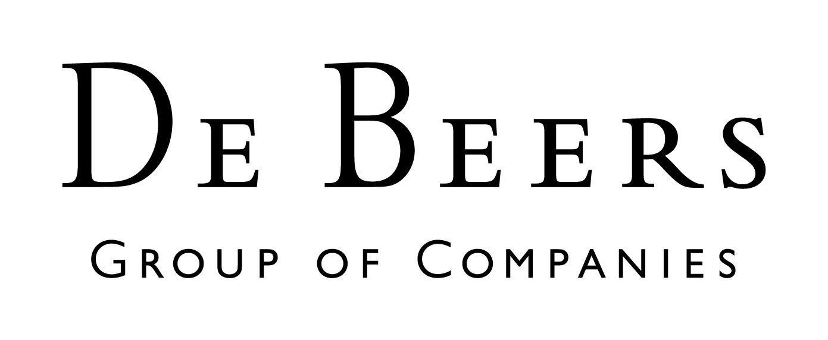
Andrea E. Ostheimer, Director Department Sub-Saharan Africa, Konrad-Adenauer-Stiftung

